To find the impedance diagram for a series R-C circuit or an R-L Circuit. You must first find the impedance of the components in the circuit. An example R-C circuit is shown in Figure 1.

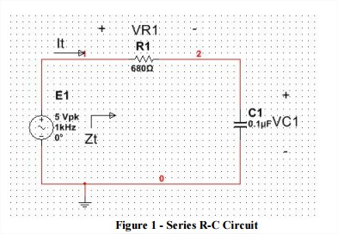

First the impedance of C1 must be found. This can be done using $Z=1/(ωC)$ to solve for the impedence which in this case means $Z=1/(2π*1kHz*.1μF)$ or $Z=628.32 μΩ$. The impedence diagram would look like the hand drawn diagram below.

An example R-L circuit is shown in Figure 2.

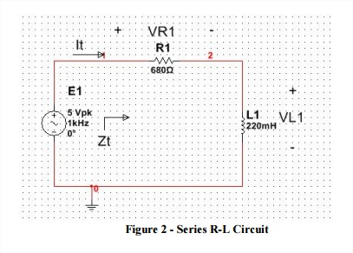

First the impedance of L1 must be found. This can be done using $Z=(ωL)$ to solve for the impedence which in this case means $Z=(2π*1kHz*220 mH)$ or $Z=1382Ω$. The impedence diagram would look like the hand drawn diagram below.